POSTURAL SCREENING WORKSHEET |  |  |  |  |  |  |  |  | Under Current Medical Treatment
School: |  |  |  | 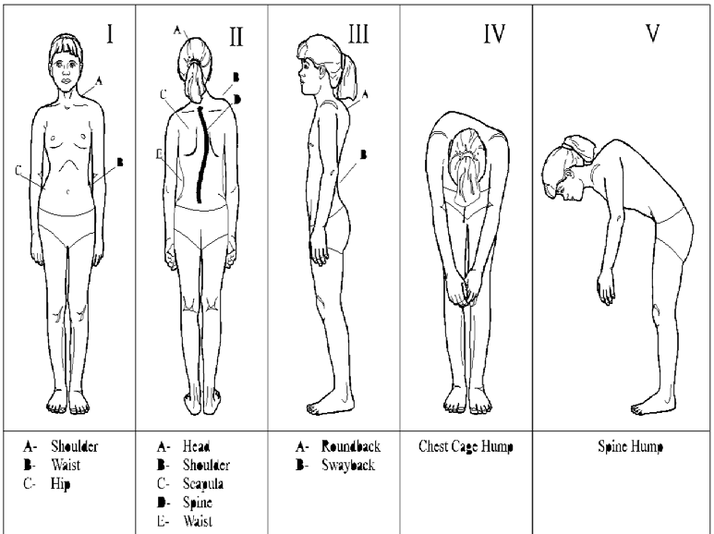 |  |  |  |  | Y/N |  | Refer for Reason Date
Address |  |  |  |  |  |  |  |  |  |  | Y/N |  | Rescreening Screener: |  |  |  | Date:
Screener: |  |  | P.E. R.N |  |  |  |  |  |  |  |  |  | Confirm Findings Y/N |  | Follow Up
Grade: Class Size: Date:
Student Name |  | Sex | DOB |  |  |  |  |  |  |  |  |  |  |  | Date Family Contacted | Date Referred to Physician | Physician's Diagnosis & Treatment Report Done | Needs School Follow Up
 |  |  |  |  |  |  | `
From: Training Material Postural Screening Program. 1996. Massachusetts Department of Public Health. Downloaded 11/28/2016 from
http://www.mass.gov/eohhs/docs/dph/com-health/school/psmanual04.pdf

